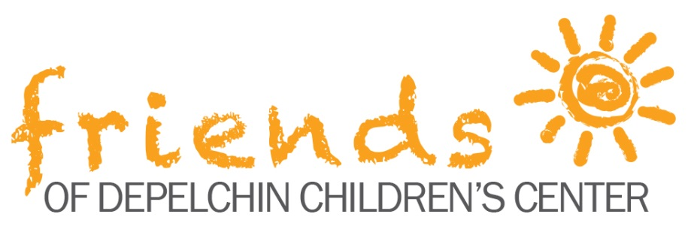
Tailgate for Tots & Charity Cornhole Tournament Sponsorship Form

Donor Information (please print) Individual Company/Organization
Name (Mr./Ms./Mrs./Dr.):
Mailing Address:
City: State: Zip:
Phone: Day _________________ Evening ________________ Email:
Please do not publish my name with this gift. I prefer not to receive e-newsletter or e-mail communications from DePelchin.

Gift Information
Sponsorship Level:

□ Heisman Sponsor - $5,000
□ Cornhole Sponsor - $3,000
□ Concession Sponsor - $1,500
□ Field Goal Sponsor - $750

Payment Information:
□ Check: Enclosed is my check in the amount of $ . (Made payable to Depelchin Children’s Center)
□ Pledge: My gift of $ _________ will be paid by October 22. (DePelchin will send reminders on September 15)
□ Charge: Please charge my credit card in the amount of $__________.
□ American Express □ Discover □ MasterCard □ Visa

^{Account number} ^{Exp. Date} ^{Security code}

^{Name as it appears on card}

Signature (required for credit card charge) ^{Date}
(For your convenience, a secure, online credit card payment may be made at www.depelchin.org.)

Matching Gifts
□ My employer/organization matches charitable contributions. (Please enclose your company’s matching gift form.)

